Simulation task
1 .Simulation of edge computing delay under local processing, cloud processing, latency, bandwidth, and task size
clc; clear; close all;
% Task size in MB
TaskSize = 1:10:100;
% System parameters
CPU_Edge = 2e9; % Edge CPU frequency (cycles/sec)
CPU_Cloud = 10e9; % Cloud CPU frequency (cycles/sec)
CyclesPerBit = 1000; % CPU cycles required per bit
Bandwidth = 10e6; % Bandwidth = 10 Mbps
Latency = 50e-3; % Network latency = 50 ms
% Convert task size from MB to bits
TaskBits = TaskSize * 8e6;
% Processing delay
EdgeProcessingDelay = (TaskBits * CyclesPerBit) / CPU_Edge;
CloudProcessingDelay = (TaskBits * CyclesPerBit) / CPU_Cloud;
% Transmission delay
TransmissionDelay = TaskBits / Bandwidth;
% Total delay for local processing
LocalDelay = EdgeProcessingDelay;
% Total delay for cloud processing
CloudDelay = Latency + TransmissionDelay + CloudProcessingDelay;
% Display results
disp('Task Size (MB) Local Delay (sec) Cloud Delay (sec)');
for i = 1:length(TaskSize) fprintf('%10d %20.4f %20.4f\n', ... TaskSize(i), LocalDelay(i), CloudDelay(i)); end
% Plot delay comparison figure;
plot(TaskSize, LocalDelay, '-o', 'LineWidth', 2); hold on;
plot(TaskSize, CloudDelay, '-s', 'LineWidth', 2);
grid on;
xlabel('Task Size (MB)'); ylabel('Total Delay (seconds)'); title('Edge Computing Delay: Local Processing vs Cloud Processing');
legend('Local Processing', 'Cloud Processing');
output
Task Size (MB) Local Delay (sec) Cloud Delay (sec)
1 4.0000 1.6500
11 44.0000 17.6500
21 84.0000 33.6500
31 124.0000 49.6500
41 164.0000 65.6500
51 204.0000 81.6500
61 244.0000 97.6500
71 284.0000 113.6500
81 324.0000 129.6500
91 364.0000 145.6500
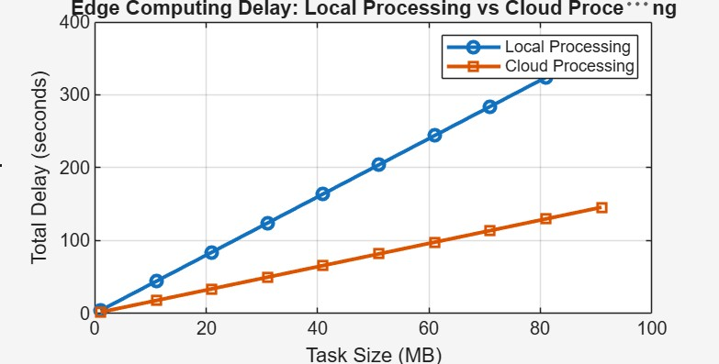
2 .Simulation of carrier aggregation performance in LTE-Advanced under single carrier, dual carrier, triple carrier, varying bandwidth, and SNR
clc; clear; close all;
% SNR range in dB
SNR = 0:5:30;
% Bandwidth of each carrier in MHz
BW = 20;
% Number of carriers
N1 = 1; % Single Carrier
N2 = 2; % Dual Carrier
N3 = 3; % Triple Carrier
% Calculate Spectral Efficiency using Shannon Capacity
SE = log2(1 + 10.^(SNR/10));
% Throughput calculation (Mbps)
Throughput_Single = N1 * BW * SE;
Throughput_Dual = N2 * BW * SE;
Throughput_Triple = N3 * BW * SE;
% Display results
disp('SNR(dB) Single Carrier(Mbps) Dual Carrier(Mbps) Triple Carrier(Mbps)');
for i = 1:length(SNR) fprintf('%5d %20.2f %20.2f %20.2f\n', ...
SNR(i), ...
Throughput_Single(i), ...
Throughput_Dual(i), ... Throughput_Triple(i)); end
% Plot Carrier Aggregation Performance figure;
plot(SNR, Throughput_Single, '-o', 'LineWidth', 2); hold on;
plot(SNR, Throughput_Dual, '-s', 'LineWidth', 2); plot(SNR, Throughput_Triple, '-^', 'LineWidth', 2);
grid on;
xlabel('SNR (dB)'); ylabel('Throughput (Mbps)');
title('LTE-Advanced Carrier Aggregation Performance');
legend('Single Carrier', 'Dual Carrier', 'Triple Carrier', ...
'Location', 'northwest');
SNR(dB) Single Carrier(Mbps) Dual Carrier(Mbps) Triple Carrier(Mbps)
0 20.00 40.00 60.00
5 41.15 82.29 123.44
10 69.19 138.38 207.57
15 100.56 201.11 301.67
20 133.16 266.33 399.49
25 166.19 332.38 498.56
30 199.34 398.69 598.03
